AWS CLOUD Installation challenges
First I have created a new instance
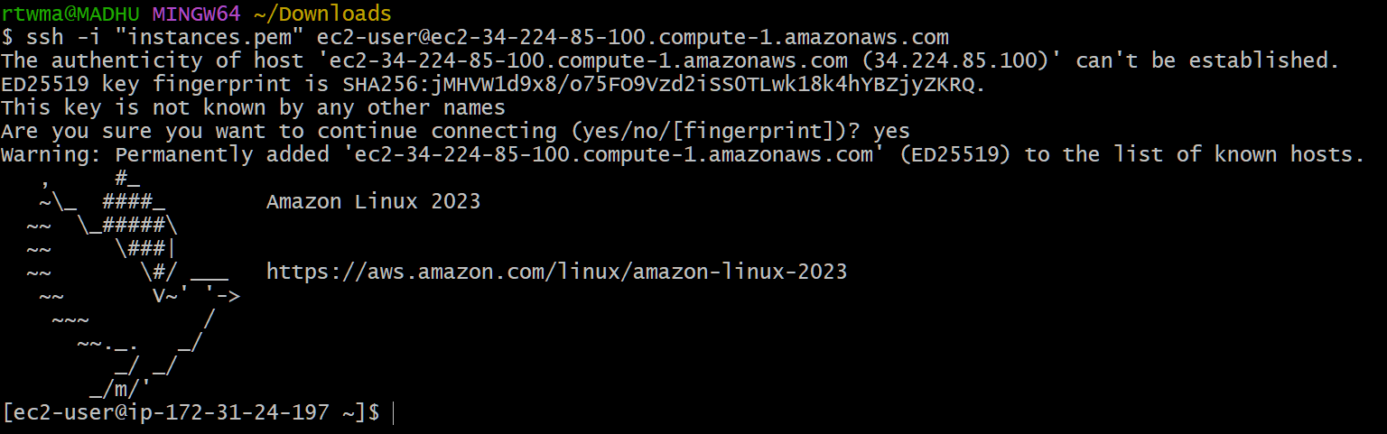
Then I have installed docker
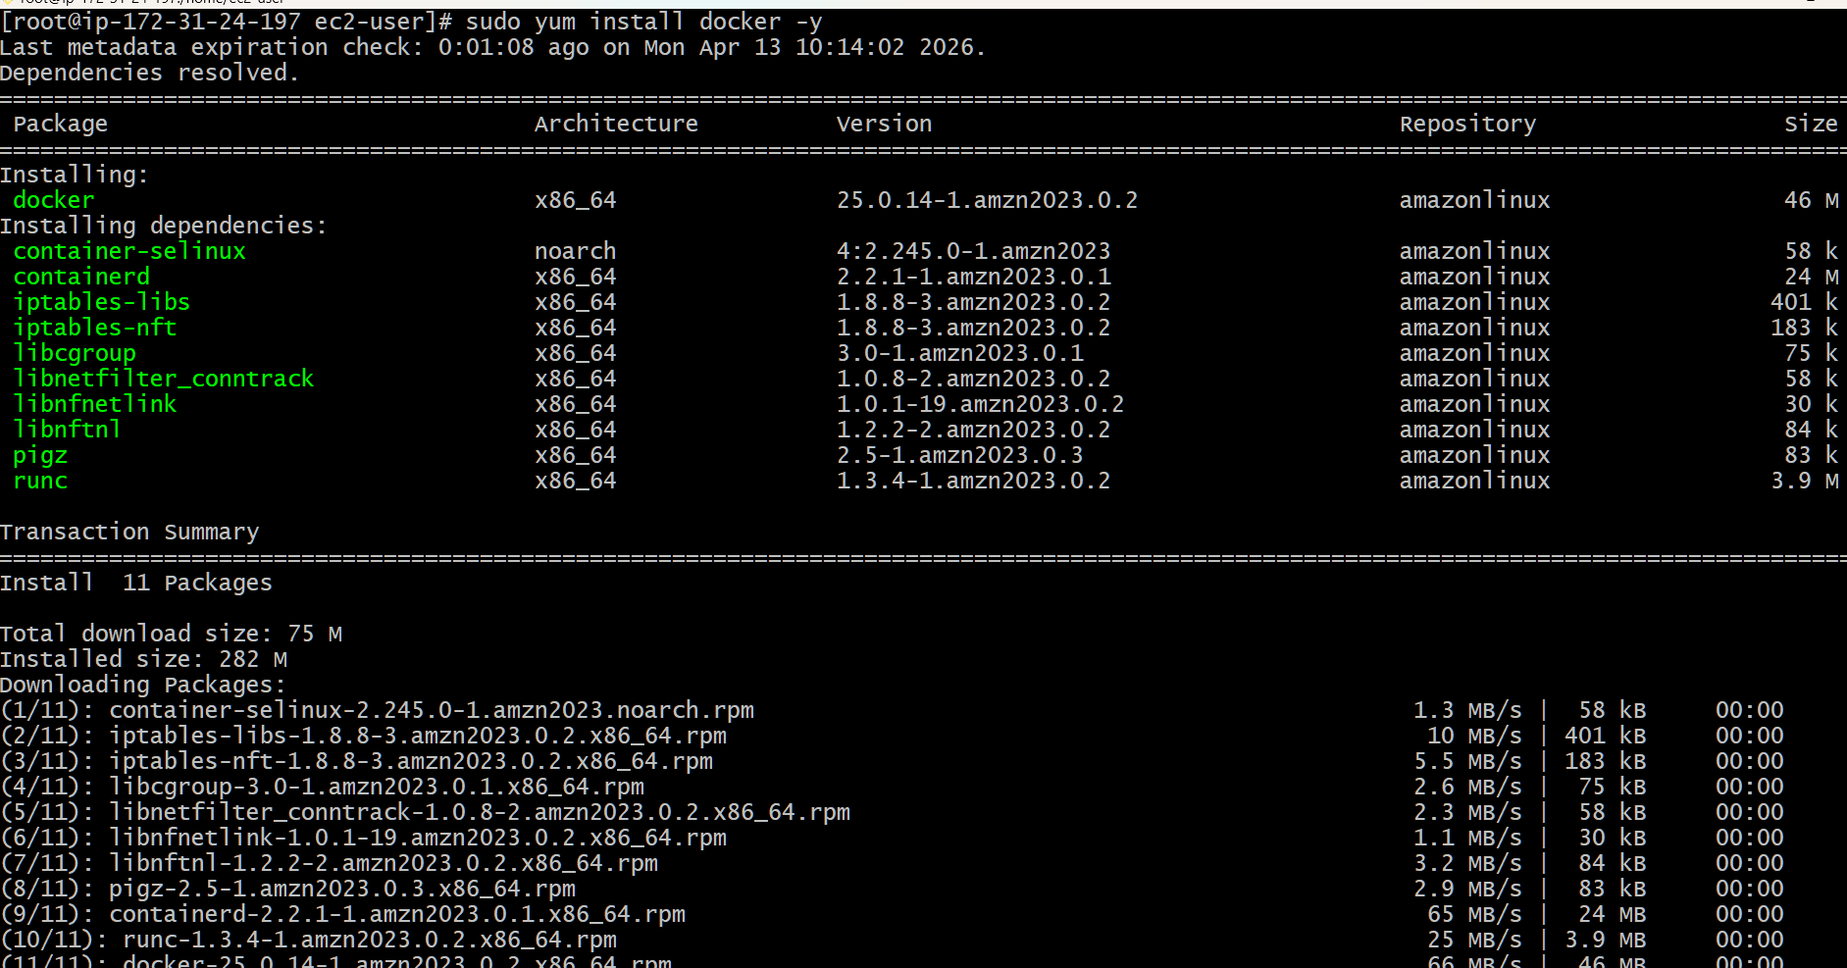
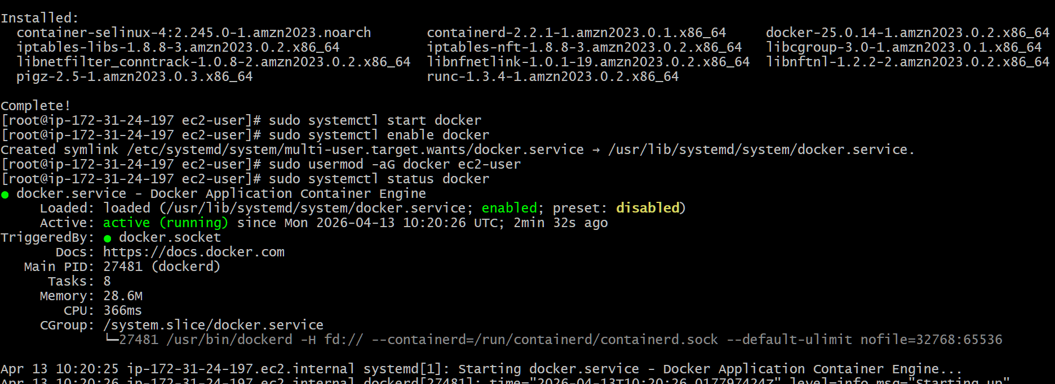
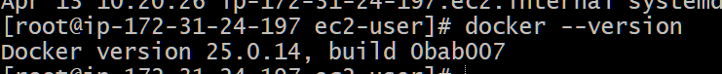
Install Jenkins.
Install Java (Corretto 17) required to run Jenkins.
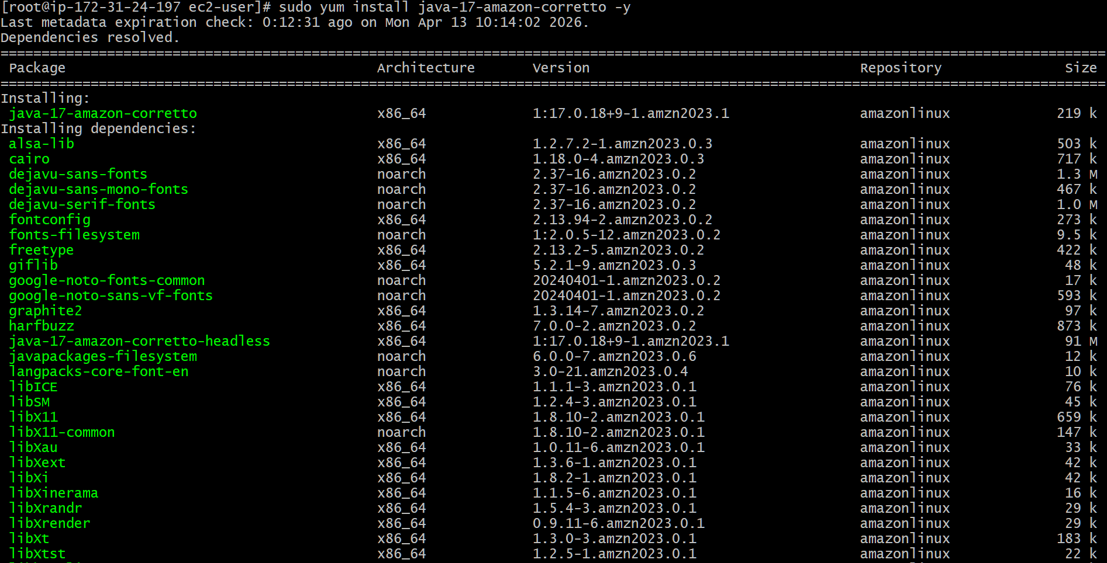
Add Jenkins repository, install Jenkins, and start the service
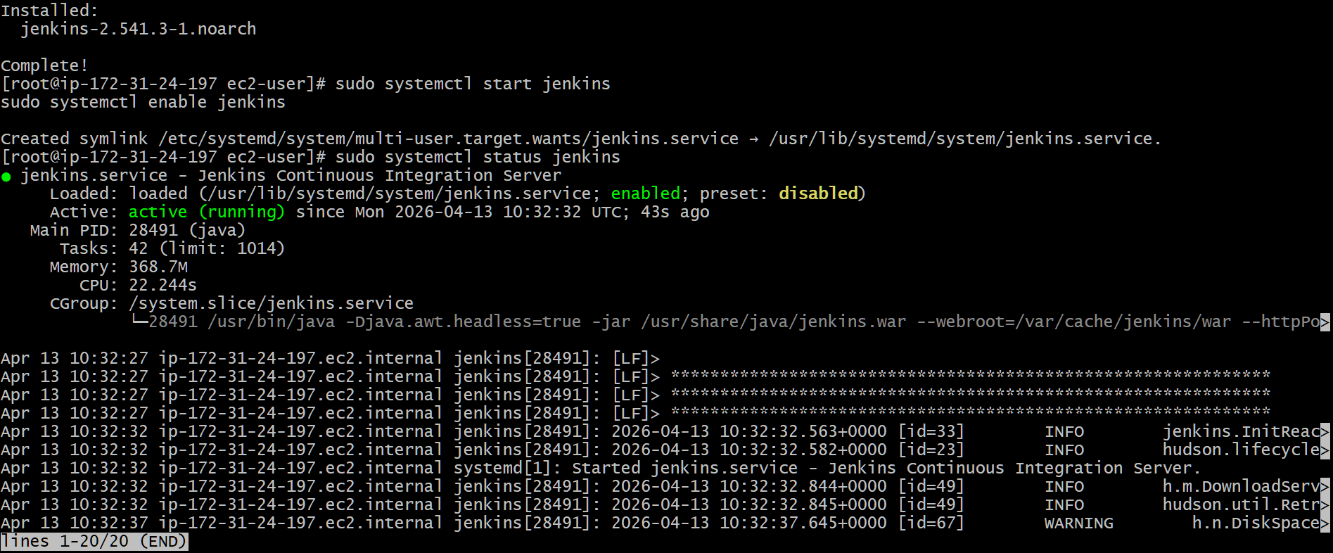
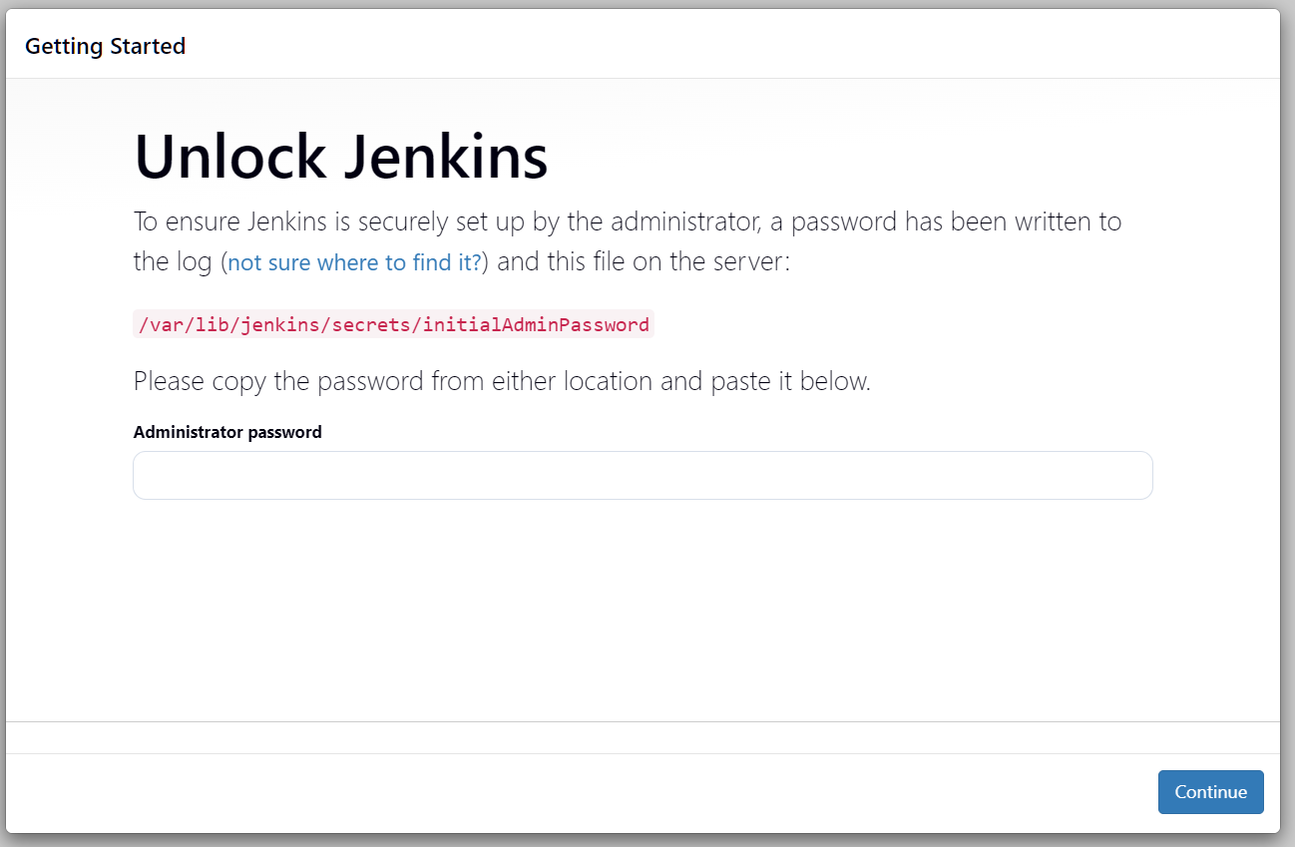

Install Apache. (httpd):
To install apache httpd sudo yum install httpd -y
To start httpd sudo systemctl start httpd
To enable httpd sudo systemctl enable httpd
To check status sudo systemctl status httpd
sudo ss -tulnp | grep 80
Go to AWS Console → EC2 → Security Group → Inbound Rules
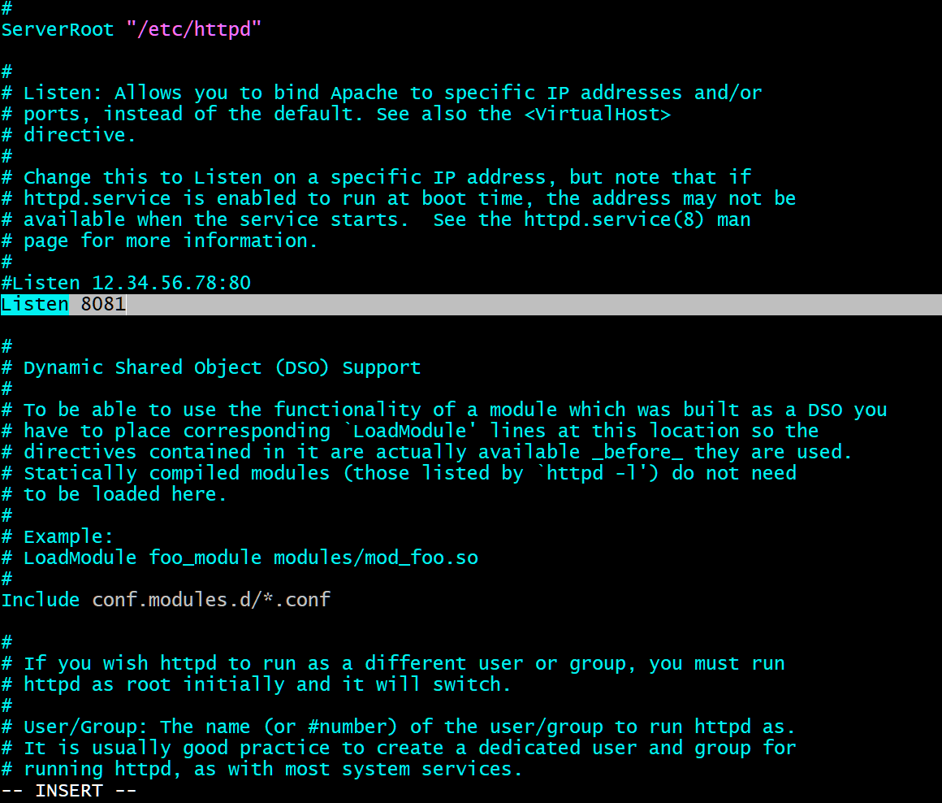

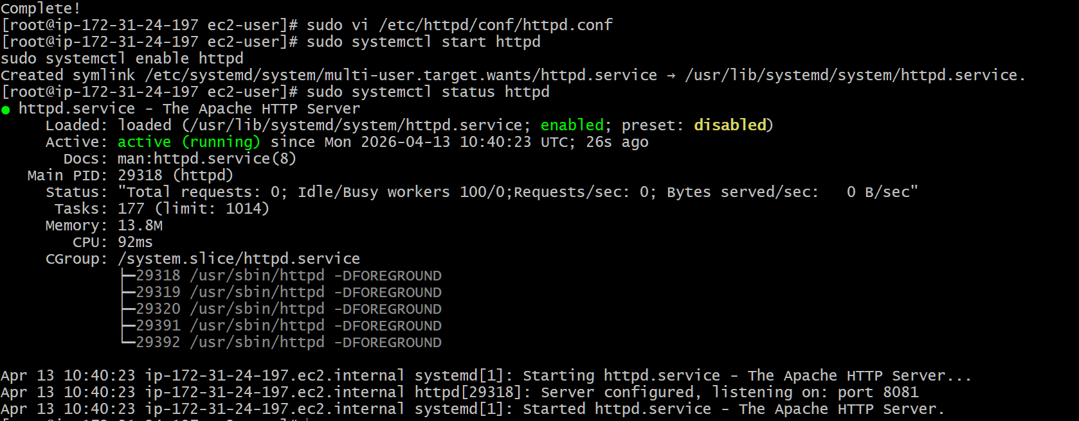
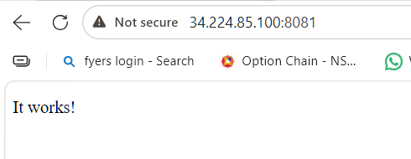

Install Nginx.
To install nginx yum install nginx -y
To check version nginx -v
To change the port number vi /etc/nginx/nginx.conf
To start systemctl start nginx
To enble systemctl enable nginx
To check the status systemctl status nginx
To see the port number running or not ss -tulnp | grep 8082
Go to AWS Console → EC2 → Security Group → Inbound Rules
Open in Browser http://100.54.245.70:8082
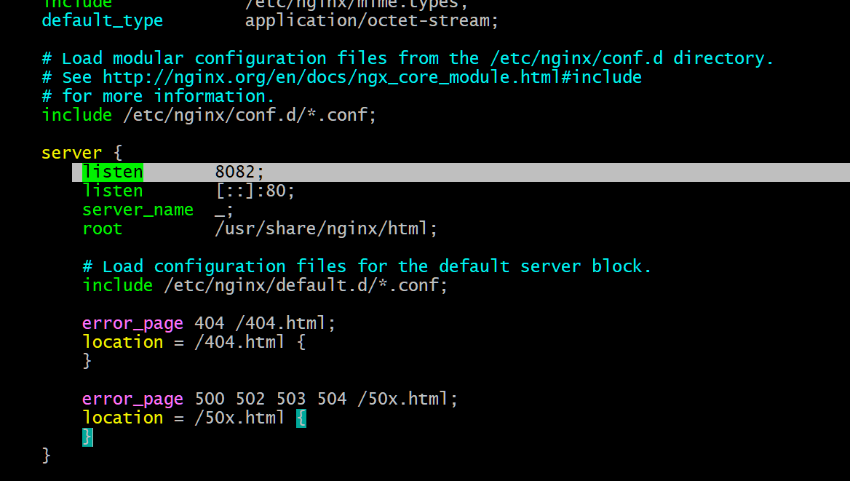
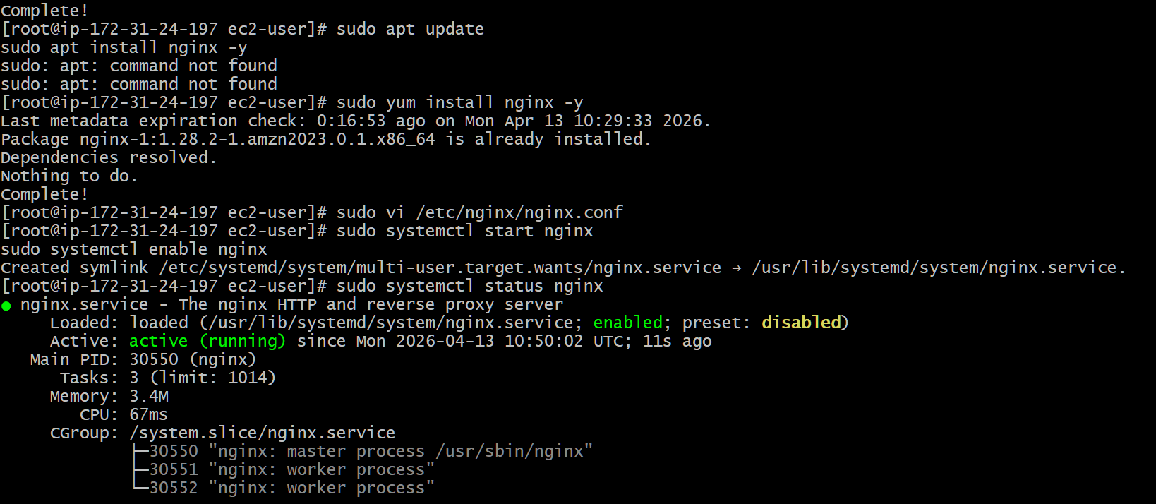
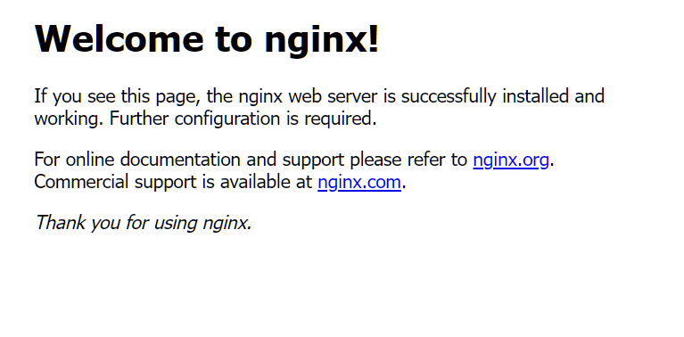
Install Apache Tomcat.
To check the java version java -version
cd /opt
with this link downloaded the apache tomcat
sudo wget
https://downloads.apache.org/tomcat/tomcat-9/v9.0.117/
bin/apache-tomcat-9.0.117.tar.gz
To untar the tar file using this coomand
sudo tar -xvzf apache-tomcat-9.0.117.tar.gz

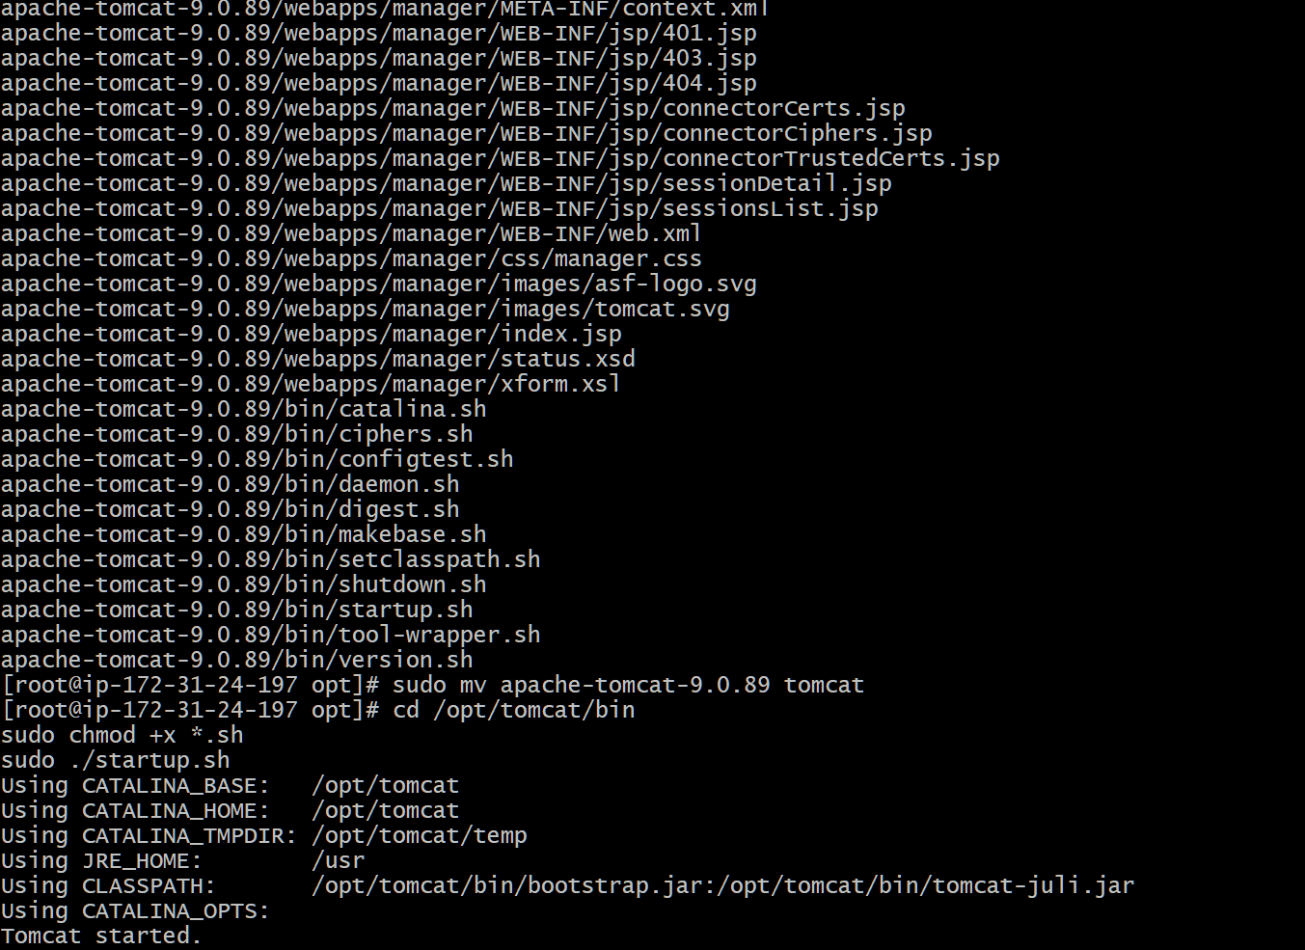
To change the name to tomcat sudo mv apache-
tomcat-9.0.117 tomcat
sudo chmod +x /opt/tomcat/bin/*.sh
sudo vi /opt/tomcat/conf/server.xml
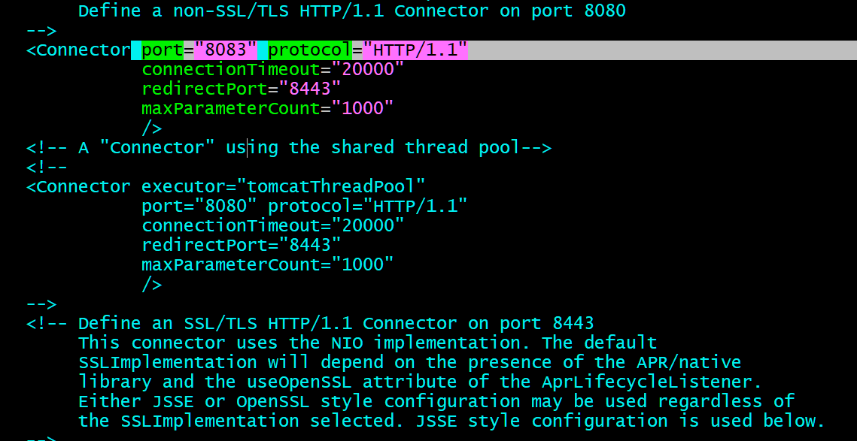
sudo /opt/tomcat/bin/startup.sh
ps -ef | grep tomcat
to grep the port number sudo ss -tulnp | grep 8083
